LAB NO 3
Text preprocessing:
Text preprocessing is the process of cleaning and preparing raw text data before it is used for analysis or machine learning. It converts messy, unstructured text into a consistent and structured format that algorithms can easily understand.
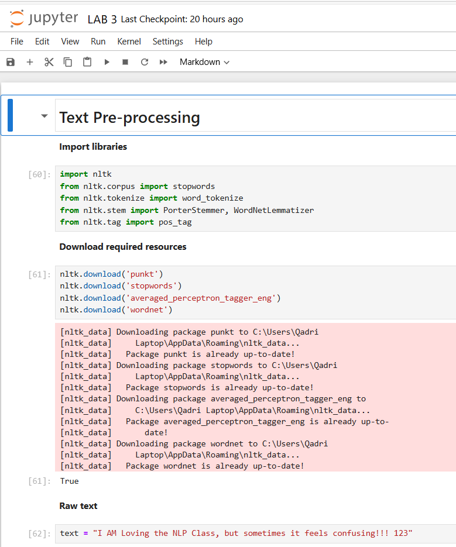

Lowercasing:
Lowercasing is the process of converting all characters in a text to lowercase letters. It helps ensure that words like “Python” and “python” are treated as the same word during text analysis.
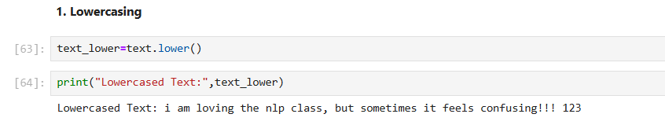
Remove numbers and punctuation:
Removing numbers and punctuation is the process of eliminating digits, symbols, and punctuation marks from text to keep only meaningful words.
This step helps reduce noise and ensures that analysis focuses on actual words rather than extra characters or numbers.
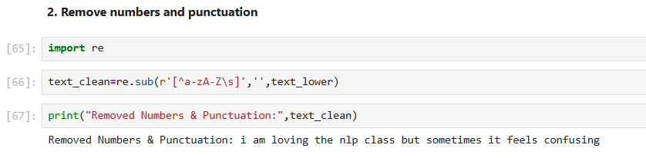
Tokenization:
Tokenization is the process of breaking down text into smaller units called tokens.
These tokens can be words, phrases, or even characters, depending on how the text is being analyzed.
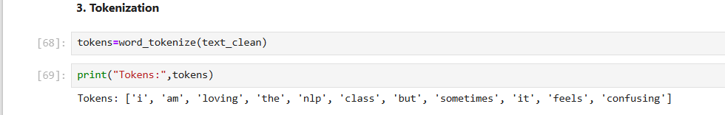
Stopword Removal:
Stopword removal is the process of eliminating common words (like “the”, “is”, “and”, “in”) that carry little meaningful information in text analysis. Removing stopwords helps focus on the important words that contribute more to the meaning of the text.
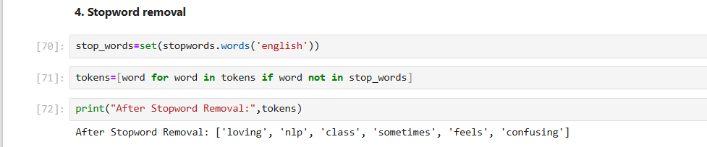
Stemming:
Stemming is the process of reducing words to their root or base form by removing prefixes or suffixes.The resulting stem may not be a real word, but it helps group similar words together for analysis.
Example:
"playing", "played", "plays" → "play"
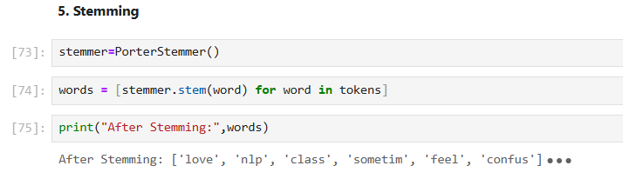
Lemmatization:
Lemmatization is the process of reducing words to their base or dictionary form (lemma) using linguistic rules and vocabulary. Unlike stemming, it always produces a valid word.
Example:
"running", "ran" → "run"
"better" → "good"
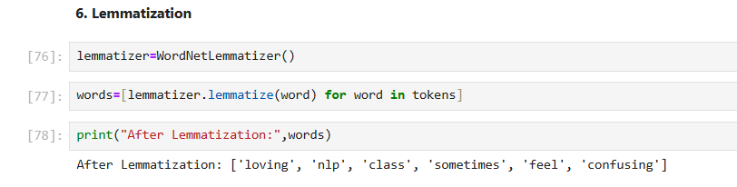
POS Tagging:
The process of labeling each word in a text with its corresponding part of speech, such as noun, verb, adjective, etc.
